Open Polyline
# Source: AI Source: Provided by: [Data Path: Persons Table -> ID Column: 1, Name_En Column: Motasem Essam] -> From: [ChatGPT] on [7/25/2026]
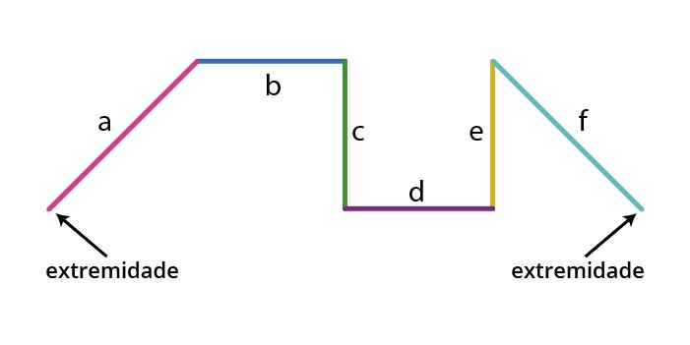
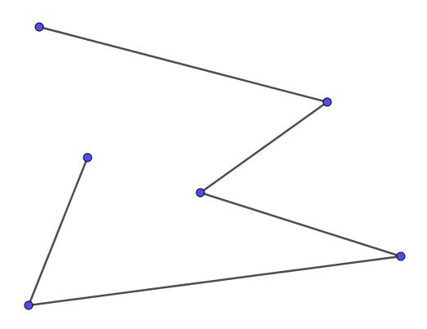
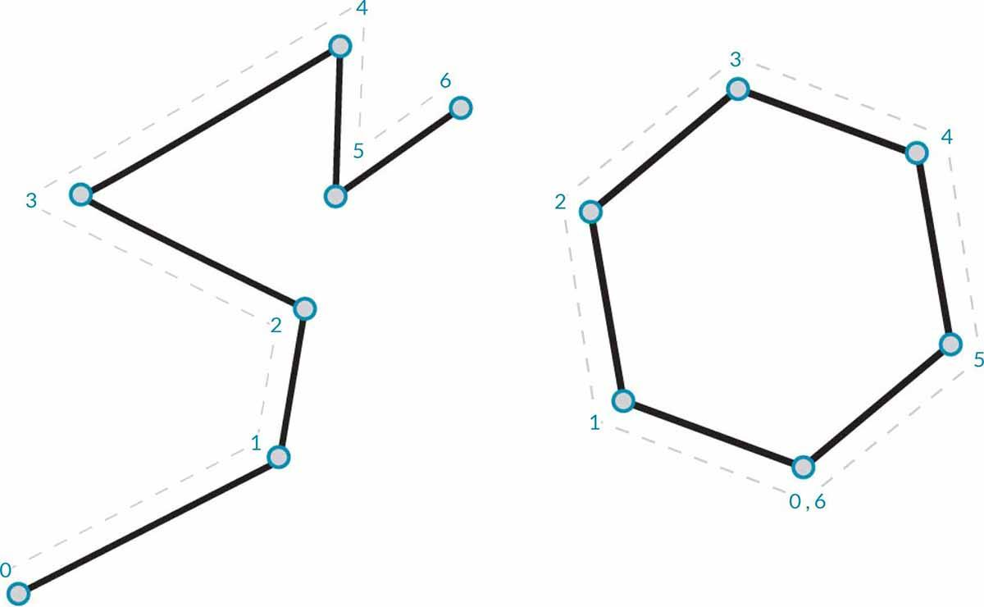

Definition
# Source: AI Source: Provided by: [Data Path: Persons Table -> ID Column: 1, Name_En Column: Motasem Essam] -> From: [ChatGPT] on [7/25/2026]
An Open Polyline is a polyline whose first and last vertices are different, meaning it does not form a closed loop. It is created by connecting two or more straight line segments end to end, but the path does not return to its starting point.
Because it is open, it does not enclose a region.

Characteristics
# Source: AI Source: Provided by: [Data Path: Persons Table -> ID Column: 1, Name_En Column: Motasem Essam] -> From: [ChatGPT] on [7/25/2026]
An open polyline:
- Consists of two or more connected line segments.
- Has distinct starting and ending vertices.
- Does not form a closed figure.
- Does not enclose an interior region.
- Has measurable total length.
- May change direction at each intermediate vertex.

Illustration
# Source: AI Source: Provided by: [Data Path: Persons Table -> ID Column: 1, Name_En Column: Motasem Essam] -> From: [ChatGPT] on [7/25/2026]
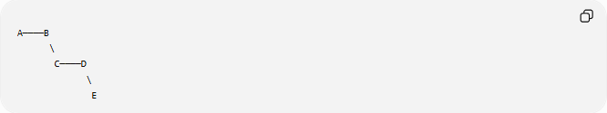
A────B
\
C────D
\
E
- Start point: A
- End point: E
Since the path does not return to A, it is an open polyline.

Components
# Source: AI Source: Provided by: [Data Path: Persons Table -> ID Column: 1, Name_En Column: Motasem Essam] -> From: [ChatGPT] on [7/25/2026]
An open polyline consists of:
- Vertices
- Straight line segments
Example:
Vertices:
$$A,B,C,D,E$$
Segments:
$$\overline{AB} \\ \overline{BC} \\ \overline{CD} \\ \overline{DE}$$

Mathematical Representation
# Source: AI Source: Provided by: [Data Path: Persons Table -> ID Column: 1, Name_En Column: Motasem Essam] -> From: [ChatGPT] on [7/25/2026]
An open polyline is represented as an ordered sequence of points:
$$P_{1},P_{2},P_{3},…,P_{n}$$
where
$$P_{1}≠P_{n}$$
Each consecutive pair forms a line segment:
$$\overline{P_{1}P_{2}},\overline{P_{2}P_{3}},…,\overline{P_{n-1}P_{n}}$$

Length of an Open Polyline
# Source: AI Source: Provided by: [Data Path: Persons Table -> ID Column: 1, Name_En Column: Motasem Essam] -> From: [ChatGPT] on [7/25/2026]
The total length equals the sum of the lengths of all connected segments.
If the segment lengths are
$$L_{1},L_{2},…,L_{n}$$
then
$$L=L_{1}+L_{2}+⋯+L_{n}$$

Examples
# Source: AI Source: Provided by: [Data Path: Persons Table -> ID Column: 1, Name_En Column: Motasem Essam] -> From: [ChatGPT] on [7/25/2026]
Example 1
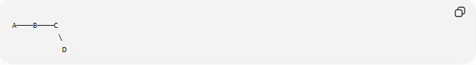
A────B────C
\
D
The first point is different from the last point.
Therefore:
$$\boxed{\text{Open Polyline}}$$

Example 2
Vertices:
$$\left(0,0\right),\left(2,1\right),\left(4,1\right),\left(5,3\right)$$
Since the last point is different from the first:
$$\boxed{\text{Open Polyline}}$$

Properties
# Source: AI Source: Provided by: [Data Path: Persons Table -> ID Column: 1, Name_En Column: Motasem Essam] -> From: [ChatGPT] on [7/25/2026]
1. Two Endpoints
An open polyline always has:
- One starting point.
- One ending point.

2. No Interior
It does not create an enclosed region.

3. Piecewise Linear
Each part is a straight line segment.

4. May Self-Intersect
An open polyline may cross itself, but it remains open unless its endpoints coincide.

Real-World Examples
# Source: AI Source: Provided by: [Data Path: Persons Table -> ID Column: 1, Name_En Column: Motasem Essam] -> From: [ChatGPT] on [7/25/2026]
Open polylines are used to represent:
- Roads.
- Walking paths.
- Rivers (approximated by straight segments).
- Electrical wires.
- GPS tracks.
- Railway lines.
- Hiking trails.
- Utility pipelines.
- Flight paths.
- Route diagrams.

Applications
# Source: AI Source: Provided by: [Data Path: Persons Table -> ID Column: 1, Name_En Column: Motasem Essam] -> From: [ChatGPT] on [7/25/2026]
Open polylines are widely used in:
- Plane Geometry
- Coordinate Geometry
- GIS (Geographic Information Systems)
- CAD (Computer-Aided Design)
- Computer Graphics
- Engineering
- Surveying
- Robotics
- Navigation Systems
- Cartography

Advantages
# Source: AI Source: Provided by: [Data Path: Persons Table -> ID Column: 1, Name_En Column: Motasem Essam] -> From: [ChatGPT] on [7/25/2026]
Studying open polylines helps to:
- Represent routes and paths.
- Approximate curved objects.
- Compute travel distance.
- Model engineering layouts.
- Build more complex geometric figures.

Limitations
# Source: AI Source: Provided by: [Data Path: Persons Table -> ID Column: 1, Name_En Column: Motasem Essam] -> From: [ChatGPT] on [7/25/2026]
An open polyline:
- Does not enclose an area.
- Cannot define an interior region.
- May require many segments to accurately approximate curves.

Comparison with Other Polyline Types
# Source: AI Source: Provided by: [Data Path: Persons Table -> ID Column: 1, Name_En Column: Motasem Essam] -> From: [ChatGPT] on [7/25/2026]
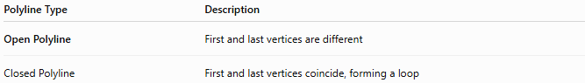
Polyline Type | Description
Open Polyline | First and last vertices are different
Closed Polyline | First and last vertices coincide, forming a loop

Key Points
# Source: AI Source: Provided by: [Data Path: Persons Table -> ID Column: 1, Name_En Column: Motasem Essam] -> From: [ChatGPT] on [7/25/2026]
- An Open Polyline is a connected sequence of straight line segments.
- The starting point and ending point are different.
- It does not enclose a region.
- It has measurable total length.
- It is widely used to represent paths, routes, and networks.

Conclusion
# Source: AI Source: Provided by: [Data Path: Persons Table -> ID Column: 1, Name_En Column: Motasem Essam] -> From: [ChatGPT] on [7/25/2026]
An Open Polyline is a connected chain of straight line segments whose first and last vertices are different, so it does not form a closed loop or enclose a region. It is an essential geometric representation for modeling paths, routes, and linear features in plane geometry, coordinate geometry, engineering, surveying, GIS, CAD, computer graphics, robotics, navigation, and cartography, where accurate representation of connected linear paths is required.

